Helps build, test and deploy software applications much faster!
- Allows you to integrate changes 100x a day= Continuous Integration
- Automatically releases every change that is done= Continuous Deployment
- Ensuring the software can be reliably released at all times = Continuous Delivery
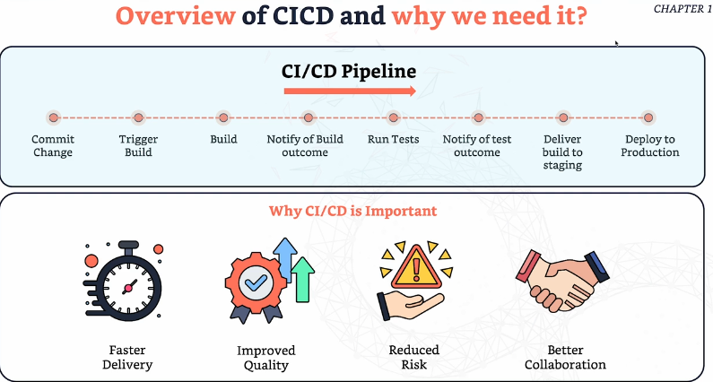
Popular CI/CD Tools:
Gitlabs
Jenkins
circleci
Travis CI
Github Actions
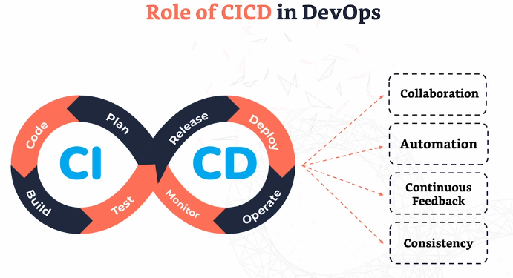
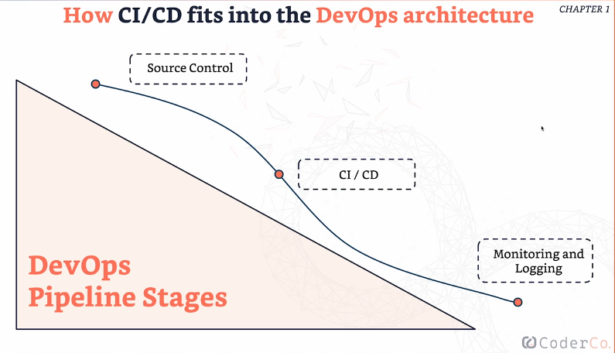
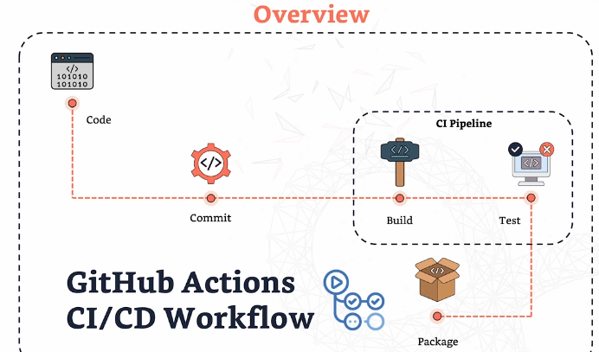
YAML- YAML Ain’t Markup Language
Used for configuration files.
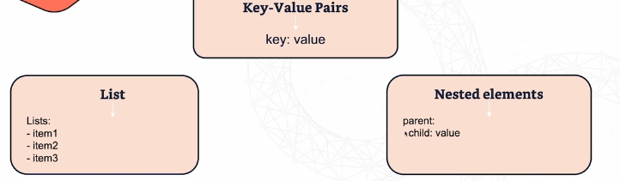
Workflow/Pipeline syntax:
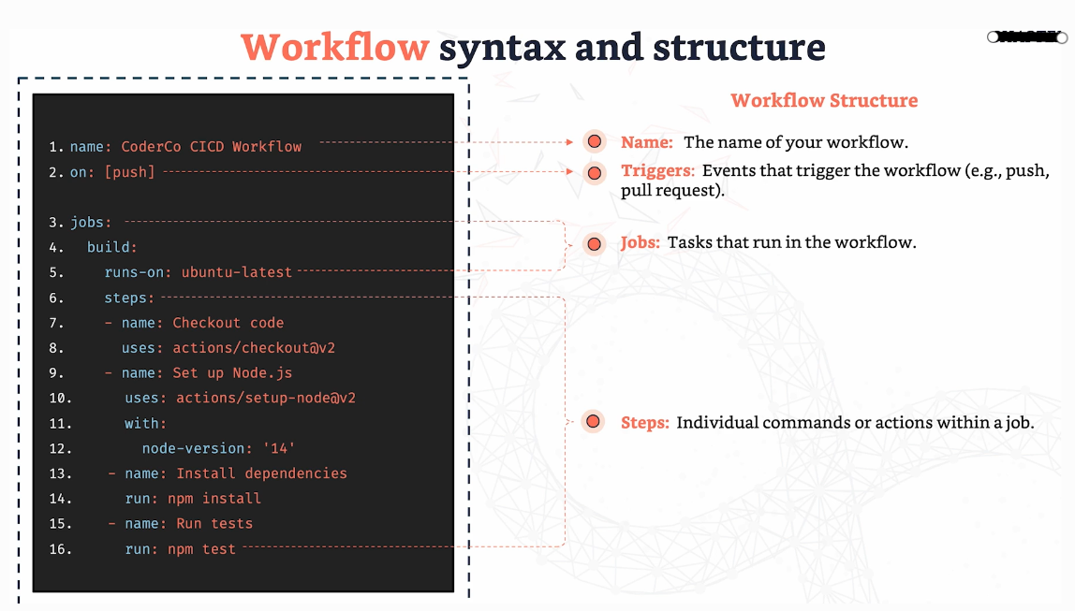
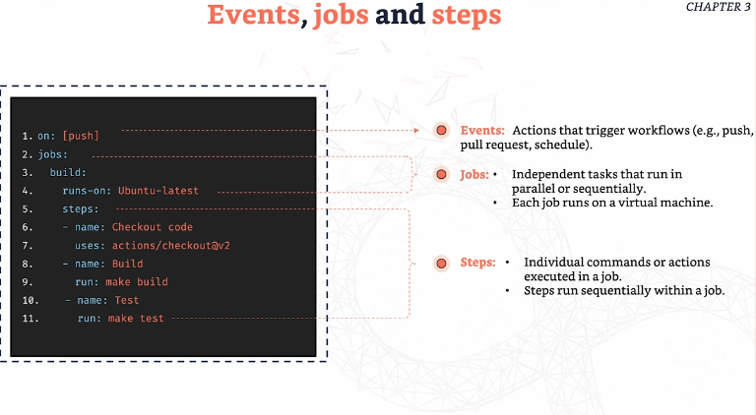
Conditions & Parallel Builds
Conditions- Controls when or how a job should run based off certain conditions.
Expressions- A way to perform calculations, manipulate strings and more within a workflow file.
